Project Neo-X

**Game Overview**

Project Neo-X is a 3D realistic shooting game with focusing on shooting combat and some puzzle through the game. A player will be controlling or switching by 2 characters which are a human and an animal for solving puzzles somehow. A player can be switching between 2 dimensions (Present and Future Time). Some simple shooting combat and a strategy boss fight. The game is referencing from Resident Evil, Final Fantasy, and Titanfall 2. The game will be setting as Fantasy and Sci-fi themes.

**Genre**

• Third-Person Shooter • Action-Puzzle

• Fantasy and Sci-fi

• Audience 15-18+ ages

**Core Mechanics**

* Running, Walking
* Shooting and Aiming Target
* Time Travel / Switching 2 Worlds (Past - Future)
* Collecting a key item
* Switching Characters (Considering)

**Gameplay**    
A player will be exploring first area and a tutorial how to use Dime-gun and how to switch between the human character and the animal character. A player will need to focus and aiming on a target before shoot. All enemies and boss will have a weakness point, a player will need to find their weakness point and target them, otherwise players can’t beat the enemies. They will be some areas that players can’t reach there. The players need to use the animal to get in there and help the players out. The purpose of Dime-Gun (Dimensional Gun) is attacking an enemy and open a gate to switch to another world. There will be a lock door in the present-day world and the player cannot open it. The player needs to go to another world, which is the future world and heck the system to get the door open and go back to the present-day world.

**Platforms**  
PC, Xbox, Playstation 4, Playstation Next Gen

**Target Audience**

Aiming for people who love to play third-person shooter and puzzle lovers. Or other people really like the game visual style as Resident Evil, Final Fantasy XV, or semi-3D realistic games.

**Story & Character**

The game character is a young lady, she is named “Sherry F.Alexaneo”. She is a spy from a future world who beloved by a cat. She has a mission from her by unknown company named X. Sherry’s mission is to collect an artifact from a mansion in the present-day world (Past World). She brings her beloved smart cat along the missions.

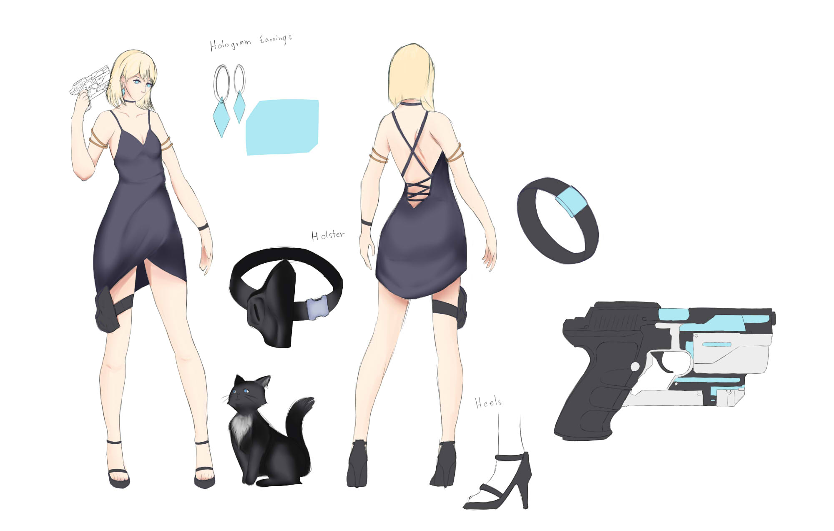

**Settings**

The game will be setting in London, England for a present-day world and Future world.

Inside a mansion

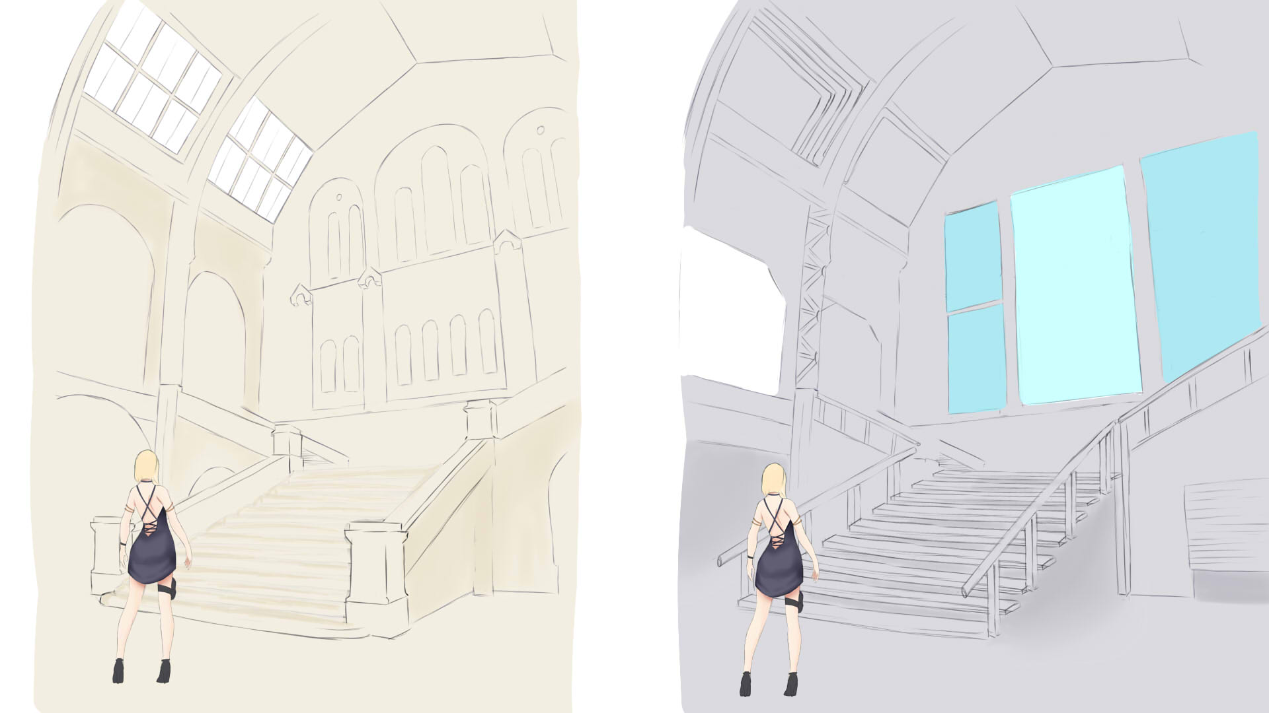

**Enemy & Boss**

All enemies and bosses are mechanic type from Future world, and they will have their weakness point to hit on it, otherwise they cannot be hurt. When during an enemy fight, the player not allow to switch a dimension, must finish them first.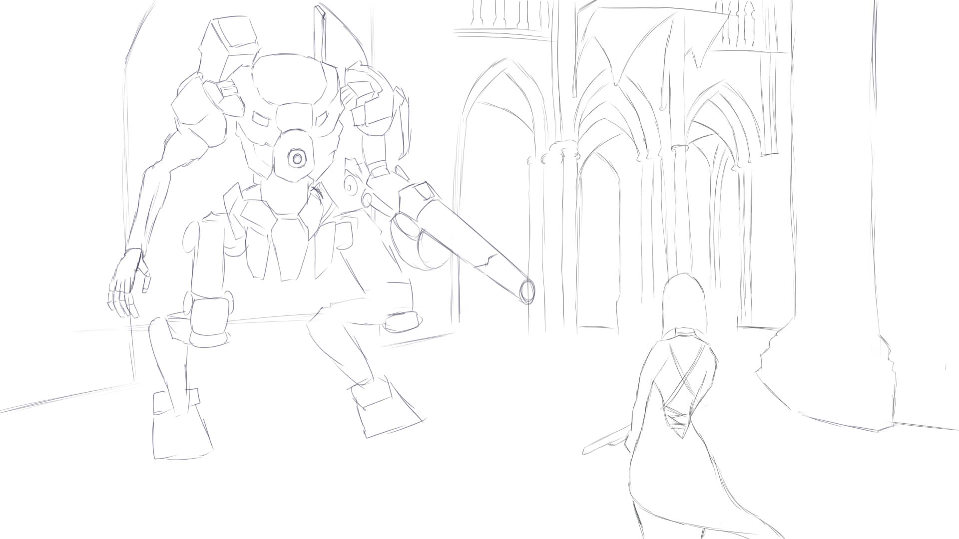

**Combat System**

Attacks – A player will be using the Dime-Gun to attack an enemy by aiming or locking target on the weakness points.

Dodge and Avoiding – A player will need to dodge or avoiding on an enemy attack or boss attack Combat area – Combat fight will be only on the Future World only.

**Puzzle & Obstacles**

Puzzle of the game will be mostly appearing in Present-day World. The player is not allowed to use gun in that world, only able to change to another world.

Example of Puzzle/Level Design

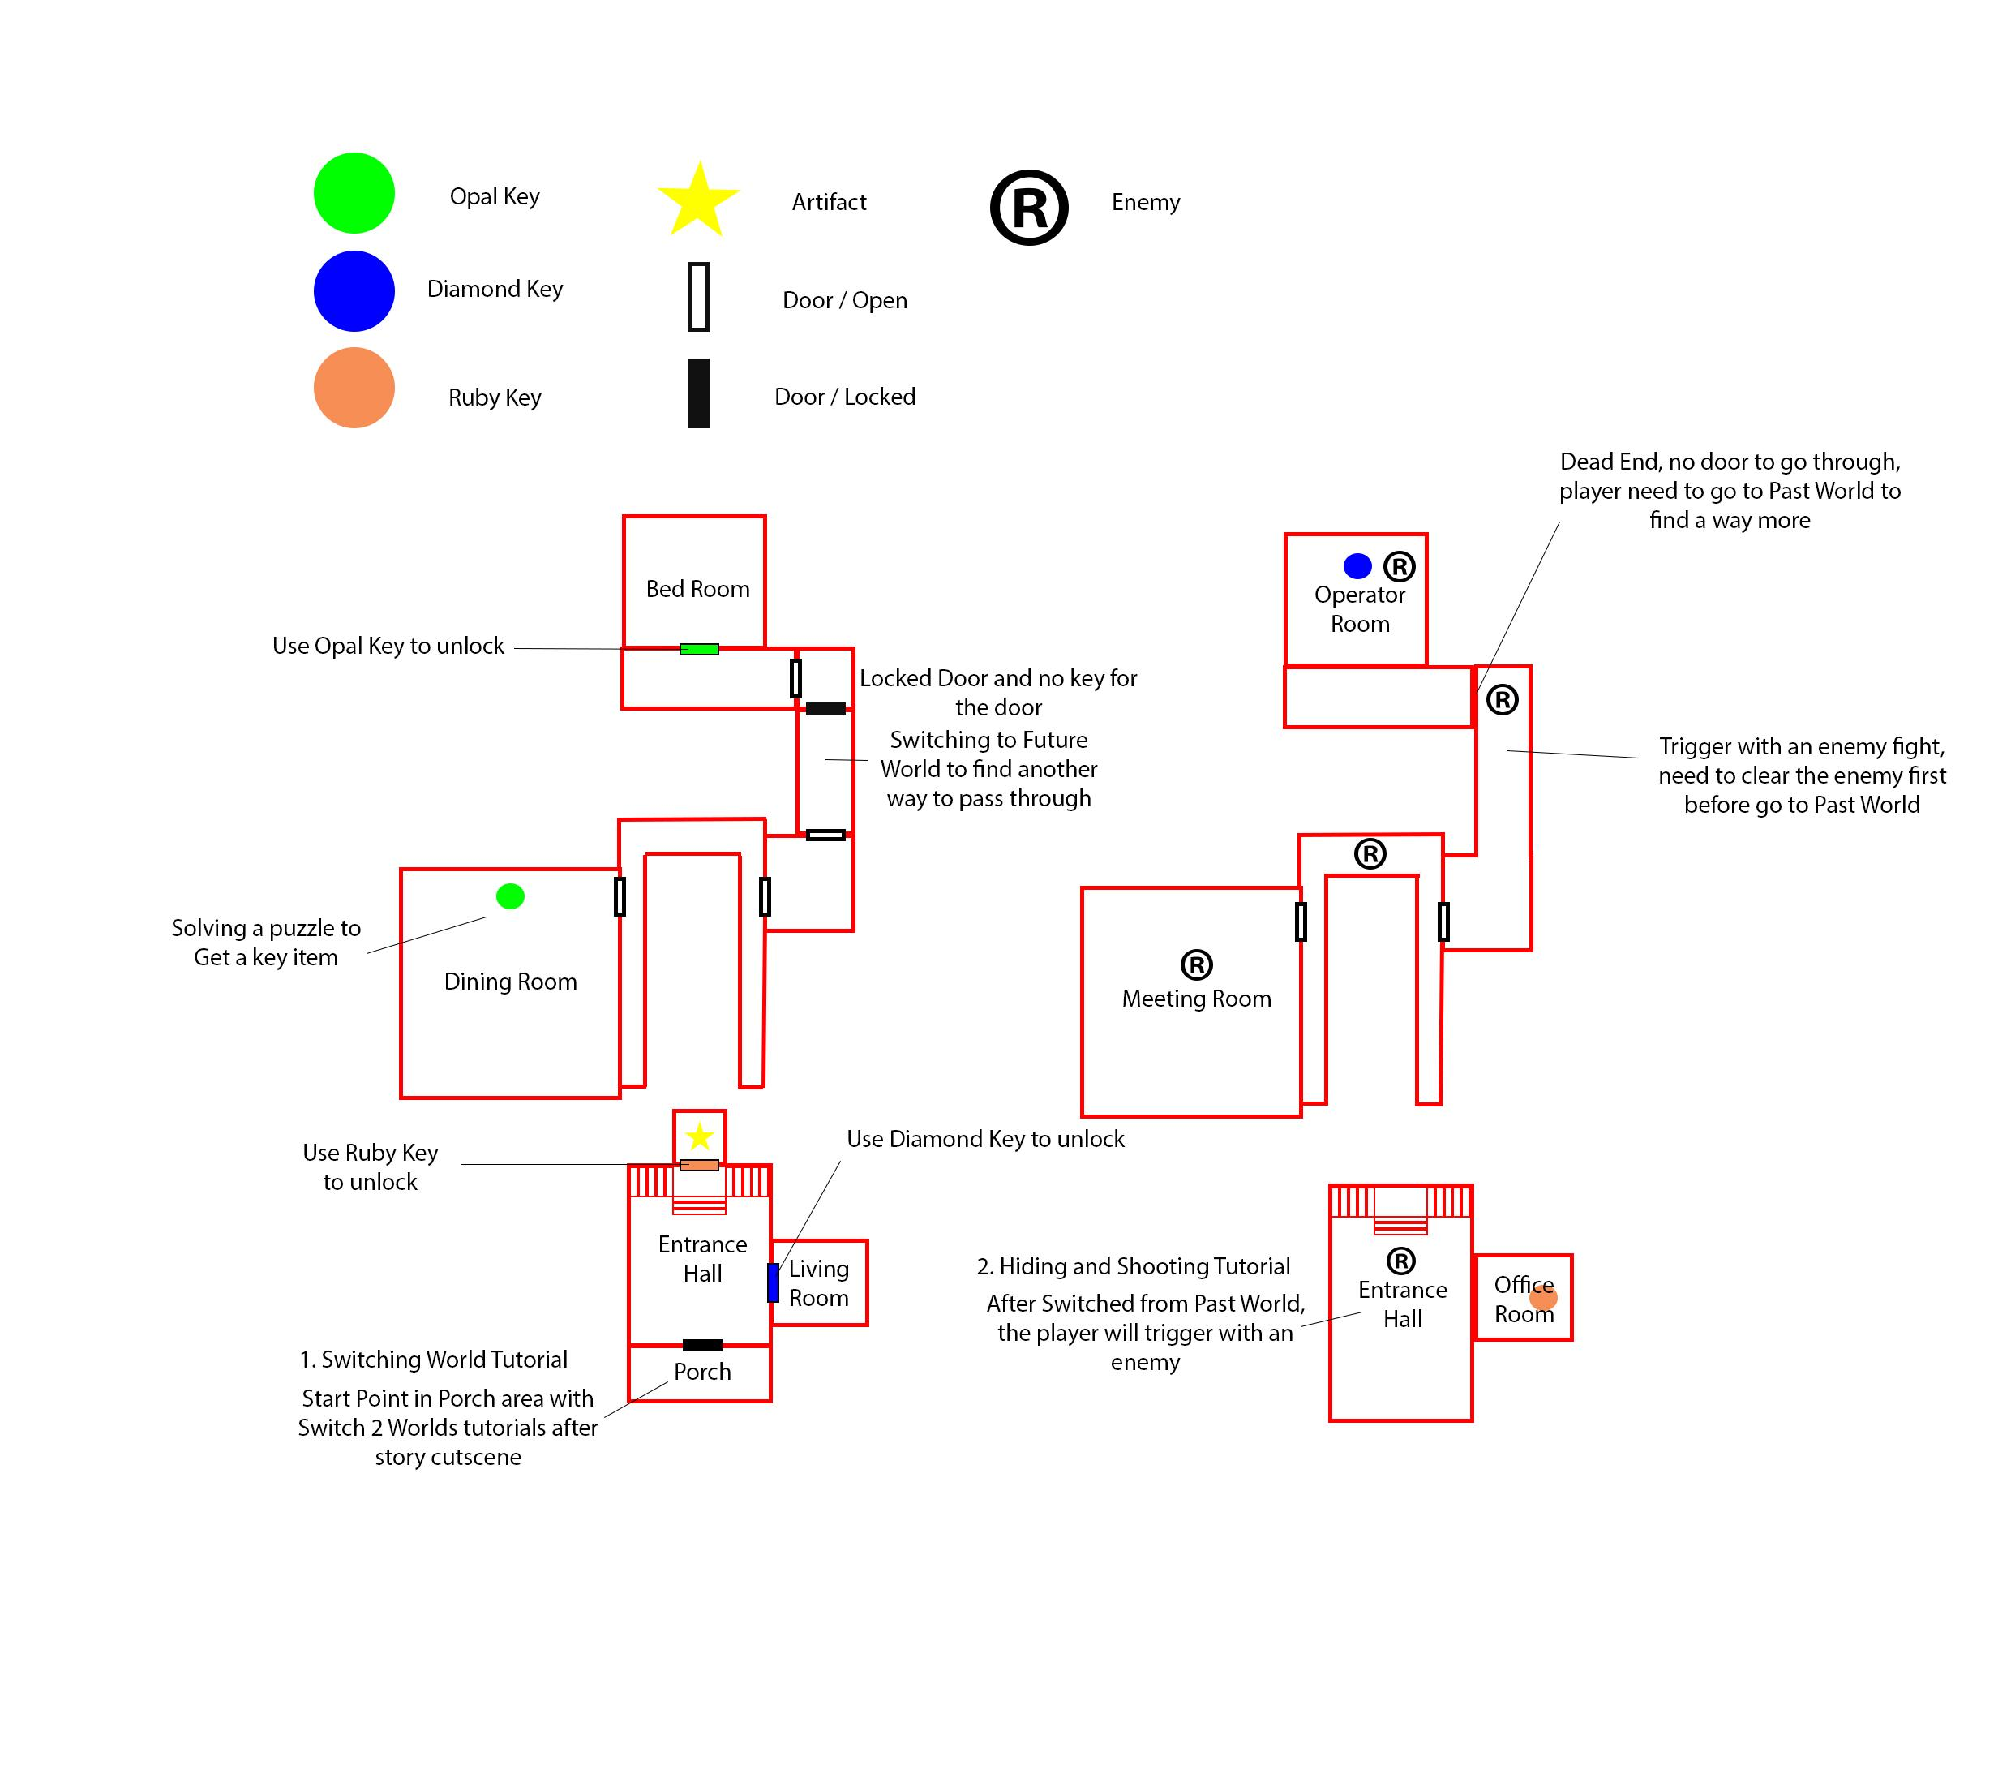

**Team Schedule**

**Week 1 - May 06 - 12 : Building Level Design**

* *Designers:* Level design, Block up environment, Puzzles, Sketches for enemy & environment & character;
* *Programmers:* Movement, Controllers, Camera, Shooting, Taking cover;

**Week 2 - May 13 - 19 : Starting to Creating Assets**

* Model enemies, Finish the entrance & assets, Modeling, Design UI;
* Switching between environments, AI for enemies;

**Week 3 - May 20 - 26 : Prototype**

* Character & enemy animation, Modeling rooms & assets, Texturing;
* Puzzles, Interaction, AI for enemies, UI & health system, inventory;

**Week 4 - Jun 27 - Jun 2 : Gameplay**

* Character & enemy animation, Modeling rooms & assets, Setup all rooms & environment, Texturing, Lighting & baking light maps, Post Processing, Visual Effects ;
* Animation settings, Effects settings;

**Week 5 - Jun 3 - 9 : Menu and Story Cutscenes / Sound Effect**

* Cut scenes, Start & restart & exit menu, and sound effect/BGM to Finish everything;
* Check-points, Test & debug;
* Testing;

**Week 6 - Jun 10 - 16 : Refinement**

* Testing, Debug, Refine; Documentation Video

**Roles** (not fixed)

Aliz - Character Design and Story Cutscene

Cam - Main Programmer

Lu - Sub-Programmer, Game Assets Assistance, and VFX creator

Vivian - Game Assets Creator

Sylvia - Game Assets Creator

Alex - Game Assets Creator

**Individual Schedule**

**Aliz Ritthisri**

Week 1 - Sculpting / Creating main character and the weapon

Week 2 - Retopology and Texturing the character

Week 3 - Rigging the character and basic animation

Week 4 - Refine the character’s animations

Week 5 - Creating story cutscene (beginning / ending)

Week 6 - Refinement / Documentation Video

**Cameron Rose**

Before we start on the project I plan on setting up a Github repository and the Unity project files.

Week 1 - Implement the core mechanics of the player. (Movement/Shooting/Taking Cover)

Week 2 - Create the AI for the enemies. Get the switching between environments working.

Week 3 - Create the AI for the enemies.

Week 4 - Add the animation to fit the scripted parts of the game so far.

Week 5 - Add in check points to the game.

Week 6 - Removing bugs in the game that are found from the testing of the game.

**Alexandra O Donoghue**

Week 1 - Sketch out enemies; Design the puzzles; Start to model enemies;

Week 2 - Model & retopology for enemies; Design UI;

Week 3 - Enemy rigging & animation; Design & model assets; Help with texturing;

Week 4 - Enemy animation; Help with texturing; Make assets;

Week 5 - Help with other group members;

Week 6 - Testing & refining;

**Lu Xiao**

Week 1 - Focusing on UI system (time, health bar, menu).

Week 2 - Items interaction system ( trigger, door open, Inventory UI). Time counter and score.

Week 3 - Include interaction with the objects in the game. Modeling assistance.

Week 4 - help character animation, rigging and texture.

Week 5 - add some effect for bullet, character and Screen.

Week 6 - debug

**Sylvia Song**

Week 1 - Sketch out environment (future) & Find out what assets going to be used; Block all the rooms; Design the puzzles;

Week 2 - Finish modeling the entrance (future) & Put assets into the room;

Week 3 - Keep modeling rooms; Finish the meeting room; Help with texturing;

Week 4 - Model the hallway & power room; Make room assets; Help with texturing;

Week 5 - Refine the environment;

Week 6 - Testing & debugging;

**Vivian Chen**

Week 1 - Sketch out environment (past) & Find out what assets going to be used; Block all the rooms; Design the puzzles;

Week 2 - Finish modeling the entrance (past) & Put assets into the room; Start to model the first puzzle room (painting room);

Week 3 - Try to finish modeling all puzzle rooms (painting & sculpture rooms); Help with texturing;

Week 4 - Finish modeling puzzle rooms; Model the main room (the largest one); Model the hallway & office/study; Help with texturing;

Week 5 - Refine the environment;

Week 6 - Testing & debugging;

**Discussion**

May 29

* Two times periods, the Past World and the Future World.
* You cannot do any damage in the past.
* There are only enemies in the Future World, so you can only shoot in the Future World.
* Recharge your gun after a certain amount to shoots.
* Bullet laser gun (click left-mouse to fire / click right-mouse to aiming)
* Player can walk, run
* Take cover behind objects to avoid damage.
* Pick up and use items (items are used automatically) still considering
* Mouse - Shooting
* WASD - controlling
* No sneaking
* No locking onto targets.
* Cannot leave a fight (cannot time travel periods)
* Nothing in the future world effects the past world.
* The game ends when you get the artifact (Goal)

Additional

* Past World is focusing on puzzle only (no combat)
* Future World is focusing on shooting combat
* No puzzle in Future World (player do not have to hack/unlock a door in Future World)
* Change location setting Museum to A mansion in the Past World
* Push further more about Puzzle Design on Past World.
* Story Cutscene at the beginning and end still considering